**Inserting the data into the documents:**

MongoDB Enterprise atlas-jsun6x-shard-0:PRIMARY> db.movies.insertOne({title:'Pulp Fiction',writer:'Quentin Tarantino',year: 1994, actor:['John Travolta','Uma Thurman']})

{

"acknowledged" : true,

"insertedId" : ObjectId("6076aca4c5a48476b14cedf4")

}

MongoDB Enterprise atlas-jsun6x-shard-0:PRIMARY> db.movies.insertOne({title:'Inglorious Basterds',writer:'Quentin Tarantino',year: 2009, actor:['Brad pitt',Diane Kruger,Eli Roth]})

uncaught exception: SyntaxError: missing ] after element list :

@(shell):1:113

MongoDB Enterprise atlas-jsun6x-shard-0:PRIMARY> db.movies.insertOne({title:'Inglorious Basterds',writer:'Quentin Tarantino',year: 2009, actor:['Brad pitt','Diane Kruger','Eli Roth']})

{

"acknowledged" : true,

"insertedId" : ObjectId("6076af05c5a48476b14cedf5")

}

MongoDB Enterprise atlas-jsun6x-shard-0:PRIMARY> db.movies.insertOne({title:'The Hobbit: An Unexpected Journey',writer:'J.R.R Tolkein',year: 2012, franchise: 'The Hobbit'})

{

"acknowledged" : true,

"insertedId" : ObjectId("6076af70c5a48476b14cedf6")

}

MongoDB Enterprise atlas-jsun6x-shard-0:PRIMARY> db.movies.insertOne({title:'The Hobbit: The Desolation of Smaug',writer:'J.R.R Tolkein',year:2013,franchise:'The Hobbit'})

{

"acknowledged" : true,

"insertedId" : ObjectId("6076afe0c5a48476b14cedf7")

}

MongoDB Enterprise atlas-jsun6x-shard-0:PRIMARY> db.movies.insertOne({title:'The Hobbit: The Battle of the Five Armies',writer:'J.R.R Tolkein',year:2012,franchise:'The Hobbit',synopsis:'Bilbo and Company are forced to engage in a war against an array of combatants aand keep the Lonely Mountain from falling into the hands of a rising darkness'})

{

"acknowledged" : true,

"insertedId" : ObjectId("6076b0a2c5a48476b14cedf8")

}

MongoDB Enterprise atlas-jsun6x-shard-0:PRIMARY> db.movies.insertOne({title:''Pee Wee Herman's Big Adventure})

uncaught exception: SyntaxError: missing } after property list :

@(shell):1:29

MongoDB Enterprise atlas-jsun6x-shard-0:PRIMARY> db.movies.insertOne({title:'Pee Wee Herman's Big Adventure'})

uncaught exception: SyntaxError: missing } after property list :

@(shell):1:43

MongoDB Enterprise atlas-jsun6x-shard-0:PRIMARY> db.movies.insertOne({title:'Pee Wee Herman\'s Big Adventure'})

{

"acknowledged" : true,

"insertedId" : ObjectId("6076b0eec5a48476b14cedf9")

}

MongoDB Enterprise atlas-jsun6x-shard-0:PRIMARY> db.movies.insertOne({title:'Avatar'})

{

"acknowledged" : true,

"insertedId" : ObjectId("6076b103c5a48476b14cedfa")

}

Q1.get all docs.

MongoDB Enterprise atlas-jsun6x-shard-0:PRIMARY> db.movies.find()

{ "_id" : ObjectId("6076abf1c5a48476b14cedf3"), "title" : "Fight Club", "writer" : "Chuck Palahniuko", "year" : 1999, "actor" : [ "Brad Pitt", "Edward Norton" ] }

{ "_id" : ObjectId("6076aca4c5a48476b14cedf4"), "title" : "Pulp Fiction", "writer" : "Quentin Tarantino", "year" : 1994, "actor" : [ "John Travolta", "Uma Thurman" ] }

{ "_id" : ObjectId("6076af05c5a48476b14cedf5"), "title" : "Inglorious Basterds", "writer" : "Quentin Tarantino", "year" : 2009, "actor" : [ "Brad pitt", "Diane Kruger", "Eli Roth" ] }

{ "_id" : ObjectId("6076af70c5a48476b14cedf6"), "title" : "The Hobbit: An Unexpected Journey", "writer" : "J.R.R Tolkein", "year" : 2012, "franchise" : "The Hobbit" }

{ "_id" : ObjectId("6076afe0c5a48476b14cedf7"), "title" : "The Hobbit: The Desolation of Smaug", "writer" : "J.R.R Tolkein", "year" : 2013, "franchise" : "The Hobbit" }

{ "_id" : ObjectId("6076b0a2c5a48476b14cedf8"), "title" : "The Hobbit: The Battle of the Five Armies", "writer" : "J.R.R Tolkein", "year" : 2012, "franchise" : "The Hobbit", "synopsis" : "Bilbo and Company are forced to engage in a war against an array of combatants aand keep the Lonely Mountain from falling into the hands of a rising darkness" }

{ "_id" : ObjectId("6076b0eec5a48476b14cedf9"), "title" : "Pee Wee Herman's Big Adventure" }

{ "_id" : ObjectId("6076b103c5a48476b14cedfa"), "title" : "Avatar" }

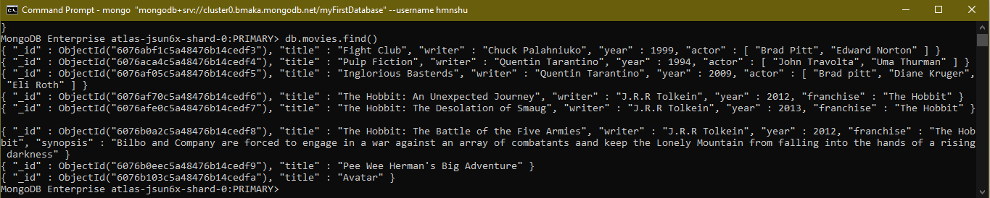

Q2. Get all doc writer set to 'Quentin Tarantino'

MongoDB Enterprise atlas-jsun6x-shard-0:PRIMARY> db.movies.find({writer:'Quentin Tarantino'})

{ "_id" : ObjectId("6076aca4c5a48476b14cedf4"), "title" : "Pulp Fiction", "writer" : "Quentin Tarantino", "year" : 1994, "actor" : [ "John Travolta", "Uma Thurman" ] }

{ "_id" : ObjectId("6076af05c5a48476b14cedf5"), "title" : "Inglorious Basterds", "writer" : "Quentin Tarantino", "year" : 2009, "actor" : [ "Brad pitt", "Diane Kruger", "Eli Roth" ] }



Q3. Get all docs where actors include ‘Brad Pitt’

MongoDB Enterprise atlas-jsun6x-shard-0:PRIMARY> db.movies.find({actor: "Brad Pitt" })

{ "_id" : ObjectId("6076abf1c5a48476b14cedf3"), "title" : "Fight Club", "writer" : "Chuck Palahniuko", "year" : 1999, "actor" : [ "Brad Pitt", "Edward Norton" ] }

{ "_id" : ObjectId("6076af05c5a48476b14cedf5"), "title" : "Inglorious Basterds", "writer" : "Quentin Tarantino", "year" : 2009, "actor" : [ "Brad Pitt", "Diane Kruger", "Eli Roth" ] }

MongoDB Enterprise atlas-jsun6x-shard-0:PRIMARY>



Q4. Get all docs with franchise set to Hobbit

MongoDB Enterprise atlas-jsun6x-shard-0:PRIMARY> db.movies.find({franchise: "The Hobbit" })

{ "_id" : ObjectId("6076af70c5a48476b14cedf6"), "title" : "The Hobbit: An Unexpected Journey", "writer" : "J.R.R Tolkein", "year" : 2012, "franchise" : "The Hobbit" }

{ "_id" : ObjectId("6076afe0c5a48476b14cedf7"), "title" : "The Hobbit: The Desolation of Smaug", "writer" : "J.R.R Tolkein", "year" : 2013, "franchise" : "The Hobbit" }

{ "_id" : ObjectId("6076b0a2c5a48476b14cedf8"), "title" : "The Hobbit: The Battle of the Five Armies", "writer" : "J.R.R Tolkein", "year" : 2012, "franchise" : "The Hobbit", "synopsis" : "Bilbo and Company are forced to engage in a war against an array of combatants aand keep the Lonely Mountain from falling into the hands of a rising darkness" }

MongoDB Enterprise atlas-jsun6x-shard-0:PRIMARY>



Q5. Get all movies released in the 90s

MongoDB Enterprise atlas-jsun6x-shard-0:PRIMARY> db.movies.find({year:{$gt:1990,$lt:2000} })

{ "_id" : ObjectId("6076abf1c5a48476b14cedf3"), "title" : "Fight Club", "writer" : "Chuck Palahniuko", "year" : 1999, "actor" : [ "Brad Pitt", "Edward Norton" ] }

{ "_id" : ObjectId("6076aca4c5a48476b14cedf4"), "title" : "Pulp Fiction", "writer" : "Quentin Tarantino", "year" : 1994, "actor" : [ "John Travolta", "Uma Thurman" ] }

MongoDB Enterprise atlas-jsun6x-shard-0:PRIMARY>

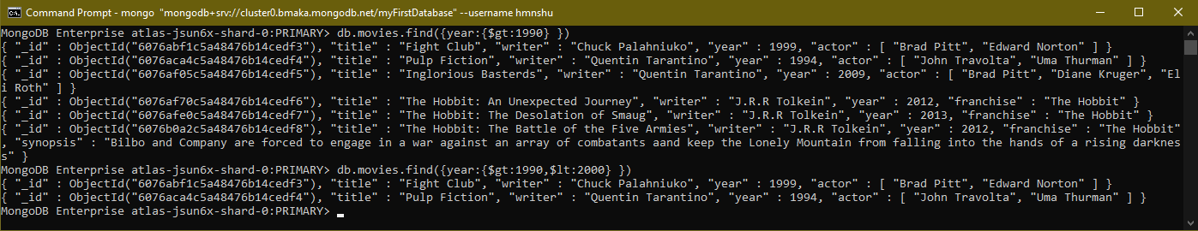

Q6. Get all movies released before the year 2000 or after 2010

MongoDB Enterprise atlas-jsun6x-shard-0:PRIMARY> db.movies.find({$or:[{year:{$lt:2000}},{year:{$gt:2010}}]})

{ "_id" : ObjectId("6076abf1c5a48476b14cedf3"), "title" : "Fight Club", "writer" : "Chuck Palahniuko", "year" : 1999, "actor" : [ "Brad Pitt", "Edward Norton" ] }

{ "_id" : ObjectId("6076aca4c5a48476b14cedf4"), "title" : "Pulp Fiction", "writer" : "Quentin Tarantino", "year" : 1994, "actor" : [ "John Travolta", "Uma Thurman" ] }

{ "_id" : ObjectId("6076af70c5a48476b14cedf6"), "title" : "The Hobbit: An Unexpected Journey", "writer" : "J.R.R Tolkein", "year" : 2012, "franchise" : "The Hobbit" }

{ "_id" : ObjectId("6076afe0c5a48476b14cedf7"), "title" : "The Hobbit: The Desolation of Smaug", "writer" : "J.R.R Tolkein", "year" : 2013, "franchise" : "The Hobbit" }

{ "_id" : ObjectId("6076b0a2c5a48476b14cedf8"), "title" : "The Hobbit: The Battle of the Five Armies", "writer" : "J.R.R Tolkein", "year" : 2012, "franchise" : "The Hobbit", "synopsis" : "Bilbo and Company are forced to engage in a war against an array of combatants aand keep the Lonely Mountain from falling into the hands of a rising darkness" }

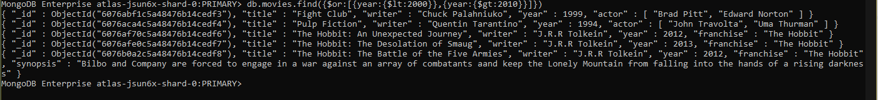

**Update Documents**

**Q1**. Add a synopsis to Hobbit………….

MongoDB Enterprise atlas-jsun6x-shard-0:PRIMARY> db.movies.update({title: 'The Hobbit: An Unexpected Journey'},{$set:{synopsis:'A reluctant hobbit, Bilbo Baggins, sets out to the Lonely Mountain with a spirited group of dwarves to reclaim their mountain home - and the gold within it - from the dragon Smaug'}})

WriteResult({ "nMatched" : 1, "nUpserted" : 0, "nModified" : 1 })

**Q2**. Add synopsis to The hobbit: The Disolation

MongoDB Enterprise atlas-jsun6x-shard-0:PRIMARY> db.movies.update({title: 'The Hobbit: The Desolation of Smaug'},{$set:{synopsis:'The dwarves, along with Bilbo Baggins and Gandalf the Grey, continue their quest to reclaim Erebor, their homeland, from Smaug. Bilbo Baggins is in possession of a mysterious and magical ring.'}})

WriteResult({ "nMatched" : 1, "nUpserted" : 0, "nModified" : 1 })



Q3. Add actor named Samuel L Jackson to the movie pulp fiction

MongoDB Enterprise atlas-jsun6x-shard-0:PRIMARY> db.movies.update({title:'Pulp Fiction'},{$set:{actor:"Samuel L. Jackson"}})

WriteResult({ "nMatched" : 1, "nUpserted" : 0, "nModified" : 1 })

MongoDB Enterprise atlas-jsun6x-shard-0:PRIMARY>



**TEXT SEARCH**

Q1. Find all movies having synopsis containing “Bilbo”

MongoDB Enterprise atlas-jsun6x-shard-0:PRIMARY> db.movies.createIndex({title:'text',synopsis:'text'})

{

"createdCollectionAutomatically" : false,

"numIndexesBefore" : 1,

"numIndexesAfter" : 2,

"commitQuorum" : "votingMembers",

"ok" : 1,

"$clusterTime" : {

"clusterTime" : Timestamp(1618404016, 9),

"signature" : {

"hash" : BinData(0,"0koVpVEtaWnJdjoG+waNpVrvVfo="),

"keyId" : NumberLong("6918340175164604419")

}

},

"operationTime" : Timestamp(1618404016, 9)

}

MongoDB Enterprise atlas-jsun6x-shard-0:PRIMARY> db.movies.find({$text:{$search:"Bilbo"}})

{ "_id" : ObjectId("6076afe0c5a48476b14cedf7"), "title" : "The Hobbit: The Desolation of Smaug", "writer" : "J.R.R Tolkein", "year" : 2013, "franchise" : "The Hobbit", "synopsis" : "The dwarves, along with Bilbo Baggins and Gandalf the Grey, continue their quest to reclaim Erebor, their homeland, from Smaug. Bilbo Baggins is in possession of a mysterious and magical ring." }

{ "_id" : ObjectId("6076b0a2c5a48476b14cedf8"), "title" : "The Hobbit: The Battle of the Five Armies", "writer" : "J.R.R Tolkein", "year" : 2012, "franchise" : "The Hobbit", "synopsis" : "Bilbo and Company are forced to engage in a war against an array of combatants aand keep the Lonely Mountain from falling into the hands of a rising darkness" }

{ "_id" : ObjectId("6076af70c5a48476b14cedf6"), "title" : "The Hobbit: An Unexpected Journey", "writer" : "J.R.R Tolkein", "year" : 2012, "franchise" : "The Hobbit", "synopsis" : "A reluctant hobbit, Bilbo Baggins, sets out to the Lonely Mountain with a spirited group of dwarves to reclaim their mountain home - and the gold within it - from the dragon Smaug" }

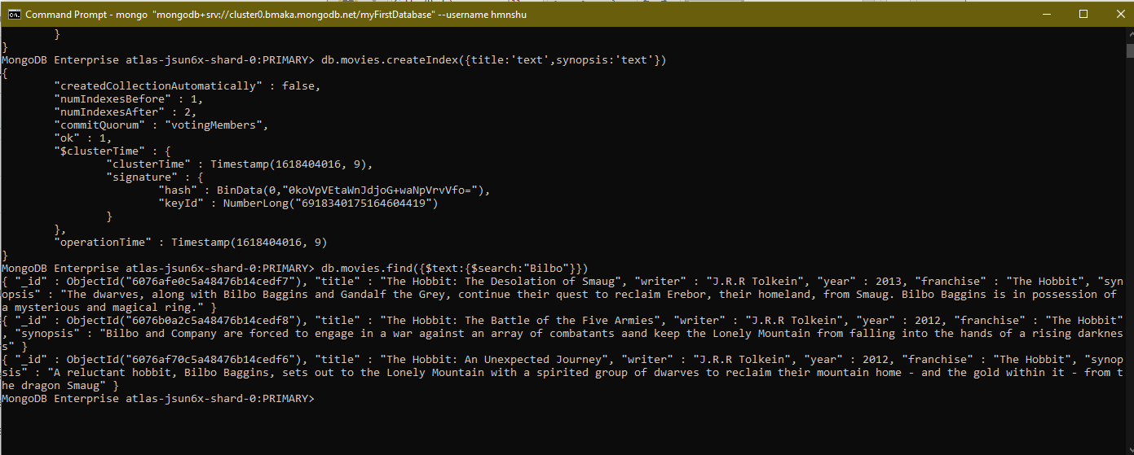

Q2. Find all movies having synopsis containing “Gandalf”

MongoDB Enterprise atlas-jsun6x-shard-0:PRIMARY> db.movies.find({$text:{$search:"Gandalf"}})

{ "_id" : ObjectId("6076afe0c5a48476b14cedf7"), "title" : "The Hobbit: The Desolation of Smaug", "writer" : "J.R.R Tolkein", "year" : 2013, "franchise" : "The Hobbit", "synopsis" : "The dwarves, along with Bilbo Baggins and Gandalf the Grey, continue their quest to reclaim Erebor, their homeland, from Smaug. Bilbo Baggins is in possession of a mysterious and magical ring." }



Q3. Find all movies having synopsis containing words “Bilbo” and not “Gandalf”

MongoDB Enterprise atlas-jsun6x-shard-0:PRIMARY> db.movies.find({$text:{$search:"Bilbo -Gandalf"}})

{ "_id" : ObjectId("6076b0a2c5a48476b14cedf8"), "title" : "The Hobbit: The Battle of the Five Armies", "writer" : "J.R.R Tolkein", "year" : 2012, "franchise" : "The Hobbit", "synopsis" : "Bilbo and Company are forced to engage in a war against an array of combatants aand keep the Lonely Mountain from falling into the hands of a rising darkness" }

{ "_id" : ObjectId("6076af70c5a48476b14cedf6"), "title" : "The Hobbit: An Unexpected Journey", "writer" : "J.R.R Tolkein", "year" : 2012, "franchise" : "The Hobbit", "synopsis" : "A reluctant hobbit, Bilbo Baggins, sets out to the Lonely Mountain with a spirited group of dwarves to reclaim their mountain home - and the gold within it - from the dragon Smaug" }

MongoDB Enterprise atlas-jsun6x-shard-0:PRIMARY>

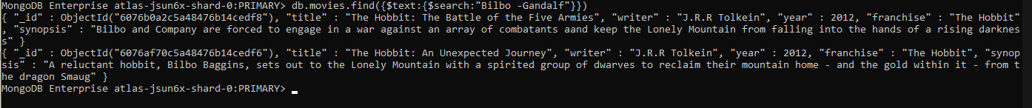

Q4. Find all movies having synopsis containing words “dwarves” or “Hobbit”

MongoDB Enterprise atlas-jsun6x-shard-0:PRIMARY> db.movies.find({$text:{$search:"dwarves hobbit"}})

{ "_id" : ObjectId("6076af70c5a48476b14cedf6"), "title" : "The Hobbit: An Unexpected Journey", "writer" : "J.R.R Tolkein", "year" : 2012, "franchise" : "The Hobbit", "synopsis" : "A reluctant hobbit, Bilbo Baggins, sets out to the Lonely Mountain with a spirited group of dwarves to reclaim their mountain home - and the gold within it - from the dragon Smaug" }

{ "_id" : ObjectId("6076afe0c5a48476b14cedf7"), "title" : "The Hobbit: The Desolation of Smaug", "writer" : "J.R.R Tolkein", "year" : 2013, "franchise" : "The Hobbit", "synopsis" : "The dwarves, along with Bilbo Baggins and Gandalf the Grey, continue their quest to reclaim Erebor, their homeland, from Smaug. Bilbo Baggins is in possession of a mysterious and magical ring." }

{ "_id" : ObjectId("6076b0a2c5a48476b14cedf8"), "title" : "The Hobbit: The Battle of the Five Armies", "writer" : "J.R.R Tolkein", "year" : 2012, "franchise" : "The Hobbit", "synopsis" : "Bilbo and Company are forced to engage in a war against an array of combatants aand keep the Lonely Mountain from falling into the hands of a rising darkness" }

MongoDB Enterprise atlas-jsun6x-shard-0:PRIMARY>

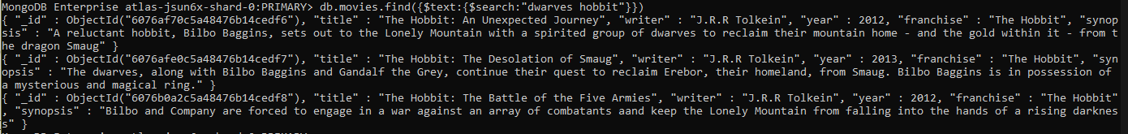

Q5. Find all movies having synopsis containing words “gold” or “ dragon ”

MongoDB Enterprise atlas-jsun6x-shard-0:PRIMARY> db.movies.find({$text:{$search:"gold dragon"}})

{ "_id" : ObjectId("6076af70c5a48476b14cedf6"), "title" : "The Hobbit: An Unexpected Journey", "writer" : "J.R.R Tolkein", "year" : 2012, "franchise" : "The Hobbit", "synopsis" : "A reluctant hobbit, Bilbo Baggins, sets out to the Lonely Mountain with a spirited group of dwarves to reclaim their mountain home - and the gold within it - from the dragon Smaug" }

MongoDB Enterprise atlas-jsun6x-shard-0:PRIMARY>



**Delete Documents**

**Q1.**delete the movie “Pee Wee Herman’s Big Adventure”

{ "acknowledged" : true, "deletedCount" : 0 }

MongoDB Enterprise atlas-jsun6x-shard-0:PRIMARY>



**Q2.**delete the movie “Avatar”

MongoDB Enterprise atlas-jsun6x-shard-0:PRIMARY> db.movies.deleteOne({title:'Avatar'})

{ "acknowledged" : true, "deletedCount" : 1 }

MongoDB Enterprise atlas-jsun6x-shard-0:PRIMARY>



**Relationship**